**Digital Project**

***Made by : Mahmoud Ebrahim Elsayed Mahmoud Manfi***

**Features:**

We some times find it difficult to solve the Boolean algebra using tabular method for variables more than 4.

So I make the program for help you to solve the problems for more than 10 variables.

The program take n variables.

The minimized answer represent as uppercase alphabets as (A,B,C,…….,Z).

So the maximum number of variable you can enter is 26

The complement is represented as single cot after the alphabet.

Example: A’B’C’DFG’.

The program use the decimal tabular method.

**Dynamic of the game:**

When you run the program:

The first he ask you the number of the variables as you see in the photo.

After that you don’t need to count the number of min terms you enter the min terms directly and when you finish you enter (-1)

After that he ask you to enter the don’t care terms and also you don’t need to know the number of them.

And after you finish you enter -1 and the program will tell you the minimize answer.

That very easy.

In the photo I don’t have don’t care so I entered -1.

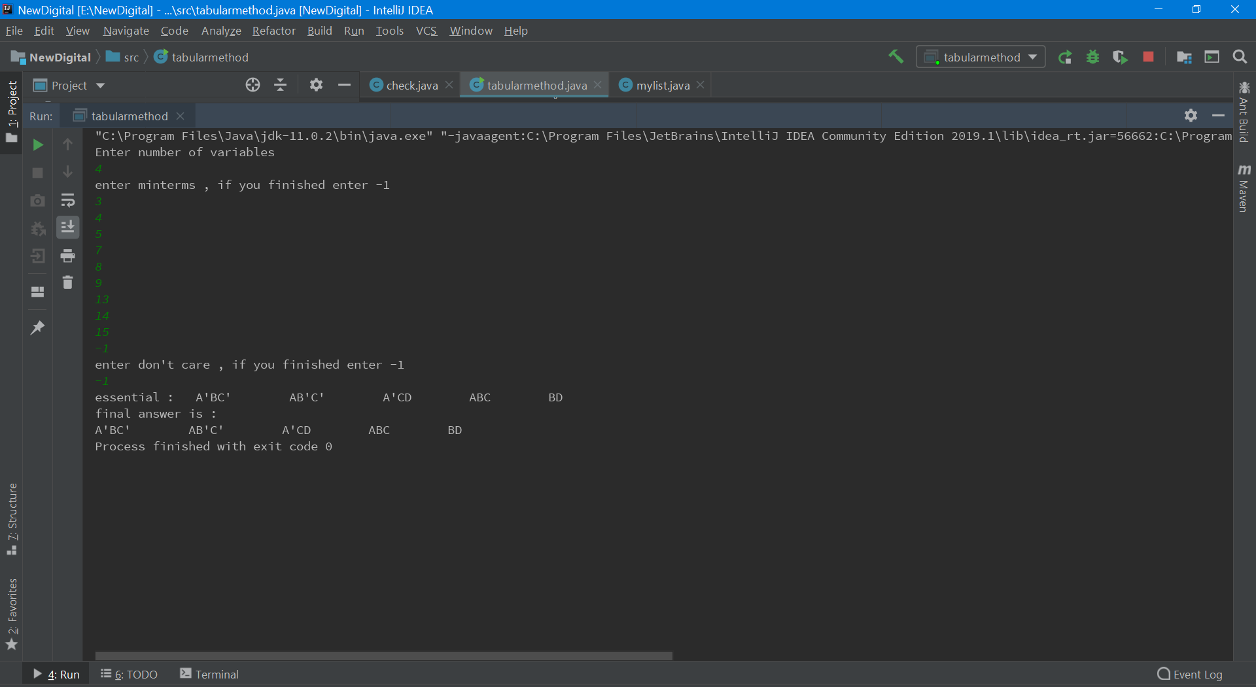

***As you see the project tell you in the first the essential prime implicants .***

***After that he tell you the final answer.***

***And if he don’t tell you that he use the Patrick method that mean the answer extract by the essential and column dominate and row dominate.***

***The program very useful when you want to know the all answer minimized .***

***He tell you all answer possible .***

***And in the example in the photo we have only one solution .***

***We will see example for all this examples in the sample run.***

**The Data structures:**

*The program have tow important class.*

*One called tabularmethod and that is the main class.*

*The other called mylist and that was very useful for my.*

*I used a lot of methods like.*

public static int fellArray(int arr[])

*I use it for make the min term array and don’t care array.*

public static int numberOfOnes(int n)

*the method count the number of ones for each number in the array min term and don’t care array.*

public static void preper(mylist x)

*this method very important to make this make multi works.*

*Like count the cost for each min term.*

*Convert the number in the decimal tabular method to character to print it in the final.*

*The essential data structure I use is array list.*

*I make array list of array list.*

*And make array list of objects to the class mylist.*

*I use the arrays in the first to take the min terms and don’t care terms.*

*I use two dimensional array to represent the table that is extract from it the column dominated and row dominated.*

***Methodology:***

* Take the number of variables.
* Take the min terms and enter -1 if finished.
* Take the don’t care terms and -1 if finished.
* Make sure from the pounds of inputs.
* Extract all prime implicants.
* Use tow dimensional array for represent the table.
* Make array list of objects of mylist.
* Make preper for the array list to count the number of ones and make the string representation for the prime implicants and count the cast.
* Extract the essential and make column dominated and row dominated if found it.
* If the essential don’t cover all the min terms use the Patrick method for the remining prime implicants.
* The code print the essential prime Implicants first.
* See if there is more than one solution.
* Print all the possible solution for the minimum cost.

**Simple runs:**

*If the user enter all the min term possible the answer is 1.*

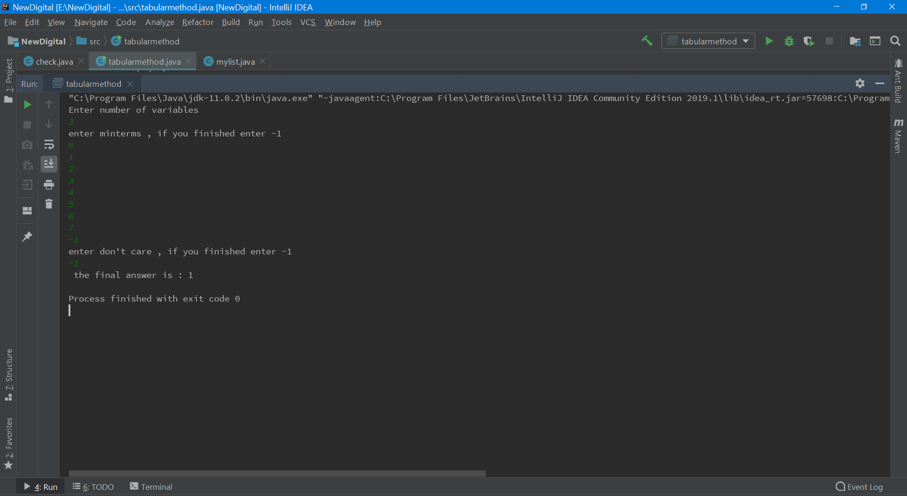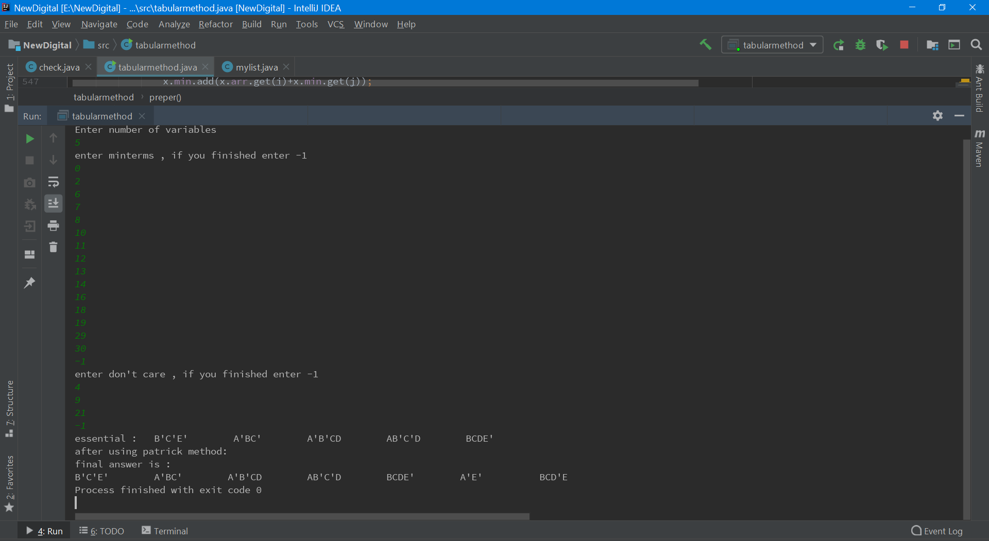

*this is example for complex minimization it is very difficult for the human to solve it .*

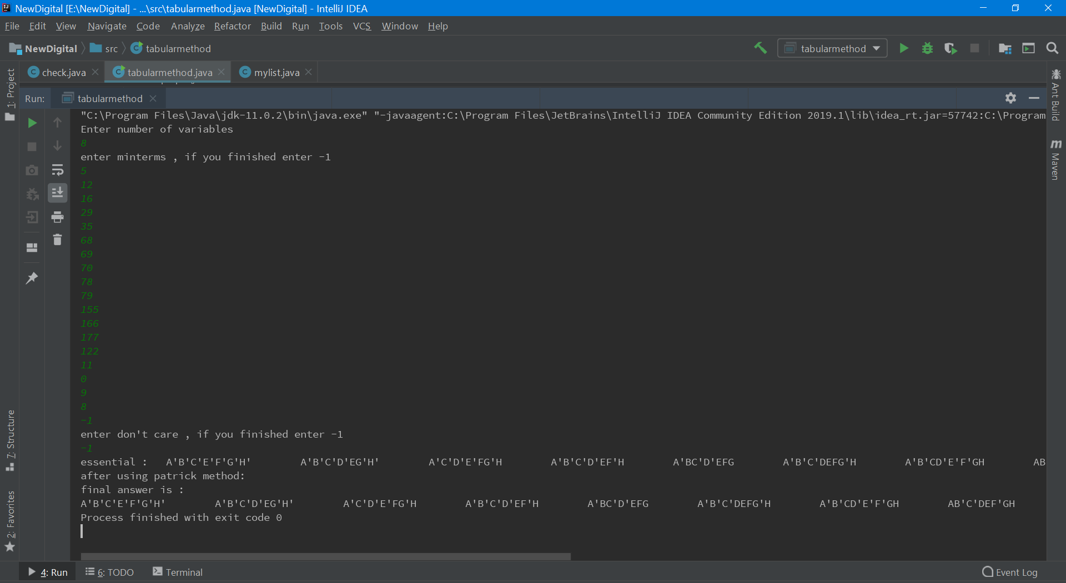

More than one solution.

